Product Datasheet
60W/12V DIN Rail Industrial Power Supply
(D60-12)
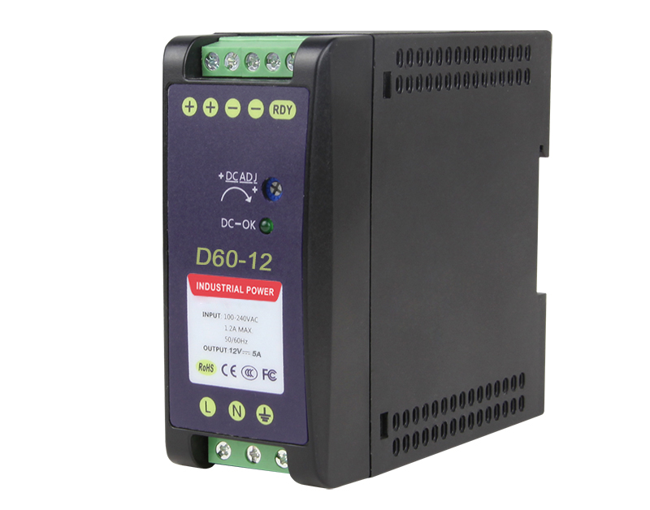
OVERVIEW
The D60-12 is an economical 60W DIN Rail industrial power supply conforming to German industrial standards. It is suitable for installation on TS-35/7.5 or TS-35/15 rails and features a full-range AC input from 90Vac to 264Vac, complying with EN61000-3-2 standards regarding EU-specified harmonic current specifications.
It uses a highly flame-retardant plastic housing to ensure safety, robustness, and durability. Based on the principle of natural air convection, the bottom and top of the housing are equipped with numerous ventilation holes to facilitate internal airflow, ensuring a high conversion efficiency of 88%, extending the power supply's lifespan, and easily handling harsh environments from -40°C to +70°C. Furthermore, this power supply features short-circuit, overcurrent, and overvoltage protection, making it suitable for a wide variety of inductive or capacitive load applications. Its comprehensive protection functions and compliance with relevant industrial control equipment certifications make it a highly competitive power supply solution for industrial applications.

FEATURE
- 90~264VAC input
- 100% full load aging test
- Meets safety and EMC standards
- High efficiency, long life, and high reliability
- Operating temperature range: -40℃~+70℃
- Protection functions: short circuit/overload/overvoltage

APPLICATION
- Factory automation
- Industrial control systems
- Electromechanical equipment
- Semiconductor manufacturing equipment

TECHNICAL SPECIFICATION

Model | D60-12
Output
Group of Output | 1
Rated Output Voltage | 12VDC
Factory Set Output Voltage | 11.4-12.6VDC (Vin: 220Vac / LOAD: 0A)
Output Rated Current | 5.0A
Output Current Range | 0-5.0A
Rated Output Power | 60W
Total Peak Output Power | Total Peak Power: 80 W (Sustained for 10 seconds at 220 VAC)
Peak Output Current | 6.66A (Sustained for 10 seconds at 220 VAC)
Ripple Noise | Peak-to-peak value ≤200mV. (Measurement method: The terminal should be connected in parallel with 0.1uF and 47uF capacitors, and the measurement should be performed at a bandwidth of 20MHz)
Output Voltage Adjustment Range | 11.8-14.2VDC
Stabilized Voltage Precision | ±5% (12.4VDC-12.6VDC)
Line Regulation | ±1% (@90-264Vac input, 0-100% load)
Load Regulation | ±5% (@90-264Vac input, 0-100% load)
Output Start-up Time | <3.0S @nominal input (100% load)
Output Hold-up Time | >20ms@115Vac, >100ms @ 230Vac (100% load )
Voltage Overshoot | ≤10%
Input
Input Voltage Range | 90-264VAC
Rated Input Voltage Range | 100-240VAC
Frequency Range | 47Hz-63Hz
Rated Frequency | 50Hz/60Hz
Starting Voltage | 90VAC
Efficiency | >85.0%@115VAC, >88.0%@ 230VAC
Input Current | <1.50A@115VAC, <0.80A@ 230VAC
Start Inrush Current | <40A@ 115VAC, <50A@230VAC
Power Factor | >0.5 (at full load)
Protection Function
Over-power Protection | 78-97W swing test (Test method: Continuously increase the output current until protection is triggered; Protection mode: swing test; automatically resumes normal operation after the overpower condition is resolved.)
Over-voltage Protection | 18-24V swing test (Short pins 1 and 2 of U8 to trigger the swing test; output returns to normal when the short is removed). Note: Do not apply an external voltage
Over-current Protection | 6.0-8.5A swing test (Test method: Continuously increase the output current until protection is triggered; Protection mode: swing test; the unit automatically resumes normal operation once the overcurrent condition is resolved.)
Short-circuit Protection | Short-circuit the power supply’s output terminals directly using a copper wire with sufficient cross-sectional area and a length of 15 cm ± 5 cm. The short-circuit may be maintained for an extended period; the unit automatically resumes normal operation once the short-circuit is resolved.
Operation Environment
Operation TEMP/ Humidity | -40℃~+70℃, 20%-95%RH non-condensing
Storage TEMP/ Humidity | -40℃~+85℃, 10%-95%RH non-condensing
Temperature Coefficient | ±0.03%/℃ (0-50℃)
Vibration | Frequency range: 10–500 Hz, acceleration: 2 G, 10 minutes per sweep cycle, with 6 sweep cycles along each of the X, Y, and Z axes
Shock | Acceleration: 20 G, duration: 11 ms, with 3 shock tests along each of the X, Y, and Z axes
Altitude | 5000 m
Safety and EMC Standard
Safety Standards | EN IEC 62368-1 □Reference ☑Certification
Insulation Strength | Input–Output: 3 kV AC/10 mA; Input–Enclosure: 1.5 kV AC/10 mA; Output–Enclosure: 0.5 kV DC/10 mA. Each test lasts 1 minute
Grounding Test | Test conditions: 32 A for 2 minutes; ground impedance: <0.1 Ω.
Leakage Current | Input to ground ≤3.5 mA; input to output ≤0.25 mA (Input 264 VAC, frequency 63 Hz)
Insulation Resistance | Input–output: 10 MΩ
Electromagnetic Interference (EMI)
Conducted Interference | EN55032, FCC Part 15 Class B
Radiated Interference | EN55032, FCC Part 15 Class B
Harmonic Current | EN61000-3-2 Class D
Conducted Immunity | EN61000-4-6 Level 3
Radiated Immunity | EN61000-4-3 Level 3 Class B
Power-Frequency Immunity | EN61000-4-8 Level 3
Electrostatic Immunity | EN61000-4-2 Level 4 Class B
Fast Pulse Groups | EN61000-4-4 Level 4 Class B
Lightning Strikes (Surge) | EN61000-4-5 Level 4 Class B
Interrupts, Dips | EN61000-4-11
Others
Dimension | 102.5*93*41mm
Net /Gross Weight | 0.27kg/ 0.31kg
Warranty | 5 years, lifelong maintenance

Notes:
- All specifications and parameters were measured at an input of 230 VAC, rated load, and an ambient temperature of 25°C.
- Ripple and noise measurement method: Use a 12' twisted-pair cable with 0.1 μF and 47 μF capacitors connected in parallel at the terminals; measurements were taken at a bandwidth of 20 MHz.
- Accuracy: Includes setting error, linear regulation, and load regulation.
- The power supply should be considered part of the system. Electromagnetic compatibility verification must be performed in conjunction with the terminal equipment.

DIMENSION

